**Documentation**

**Intro to Programming**

**Ryan Wells & Arek Gorski**

1. **User Manual.**

* Description of the game and how to play it

1. Description of Classes

* How the game was created.

1. Critical Appraisal

* A critical evaluation of the work as a group and individually.

1. **User Manual**

The task that we were set was to create a simulation of a real darts game. To achieve this we had to research the rules of a game of darts and the game starts off with each player having a total of 501 and throwing three darts each every turn until they are down to 180 then the score must end on a double or bulls’ eye. When you start the program you will be presented with a menu that displays a few options for the user to choose from these will be choosing by the user selecting a number from 1 to 3. For Example:

1. Start new Game
2. Replay the Game
3. Exit the Game

Each option will display different things such as, if the user chooses option one to start a new game then this will start a brand new game. Selecting option two to replay the game will show the scores of the previous game that the user has just been played. Choosing the third option to exit the game will display a message to the user to display that they have chosen to exit the game.

New Game

The new game option will lead the user to a new section that will ask the user how many players will be playing the game the user enters the number of players that will be playing, then they will be led to be asked for each player’s name, when each player has been assigned names they will begin the game. The first players three throws will be displayed and they will be added up and subtracted from the total that each player starts with witch is 501 then the new number will become the players total, and will carry on to the next players turn a do the same routine to get the three throws, the total of the three throws and there remain score total remaining from 501, then when each player has had their turn it will go back to first players throw. The aim of the game is to get to zero before the other player does, but for a player to win the game they must finish on a double or bulls-eye.

Replay the Game

When this option is chosen by the user you will be able to see the scores and throws of the previous game that has just been played.

Exit the Game

Choosing this option will display a message to the user that they have chosen to exit the game.

1. Description of Classes

The game starts with the display menu method which displays the menu options for the user to choose from then the program gets the users choice and then runs the next method in the code associated with the users choice.

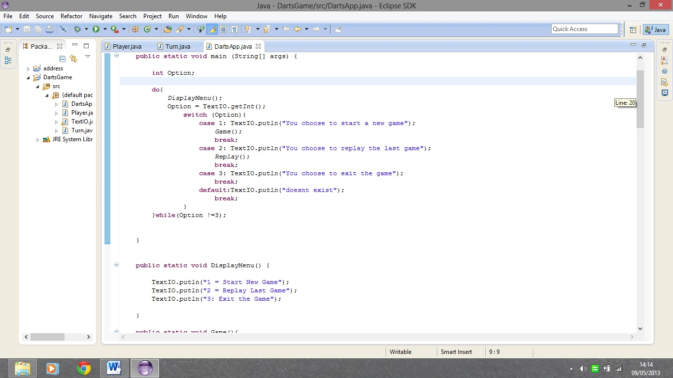

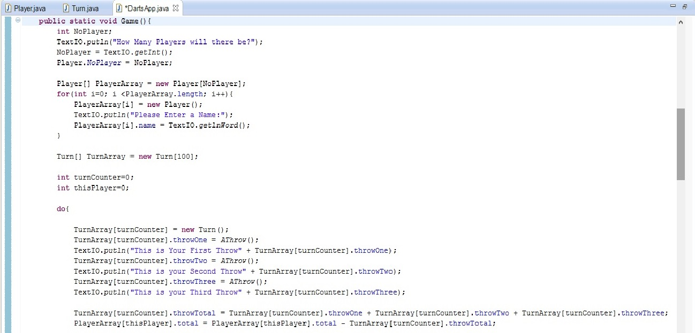If the user chooses option one for instance then the program will run the Game() method which starts with asking the user for how many players will be playing the game then asks for each player’s name, this information is the stored in an array and the data is stored in another class called player. The program then creates three throws called from another class called Turn and stores then in an array for throws for each player, the program then calls the athrow() method for the math to complete each player’s throw, then adds them together and subtracts the total of the three throws from the total that each player starts with which is 501. At the end of this method is the condition to stop the game, if the player’s total is below one.

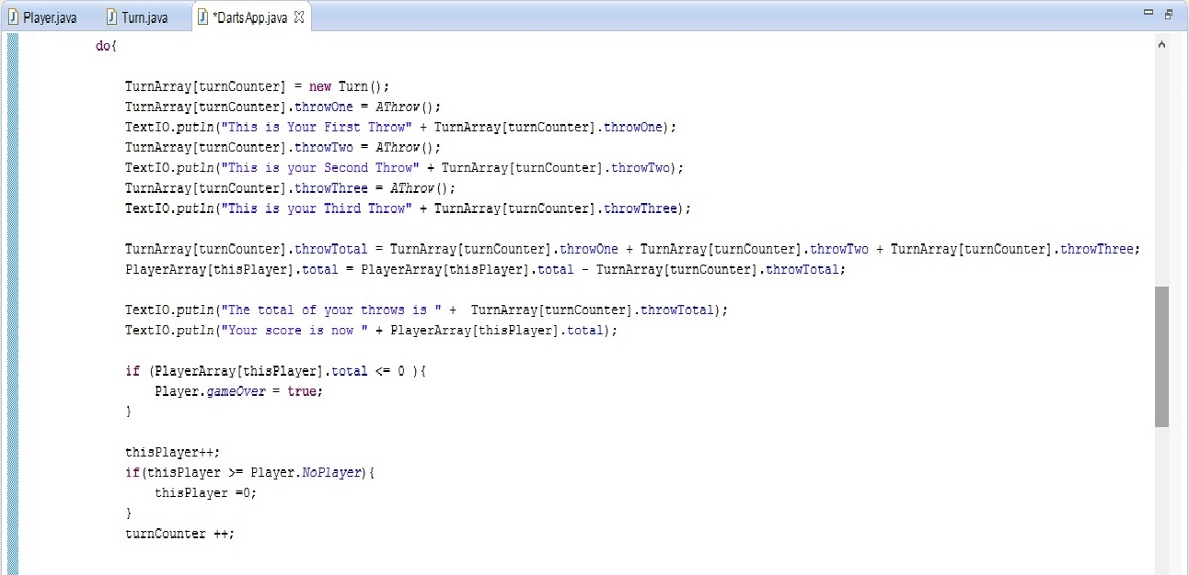

The Player class is used to store the variables used in the player array to create instances of player such as;

* An integer for the number of players there will be
* A Boolean value to decide if the game is to be played or if a player has won
* A string value for the names for each player
* A integer to store the value for each player

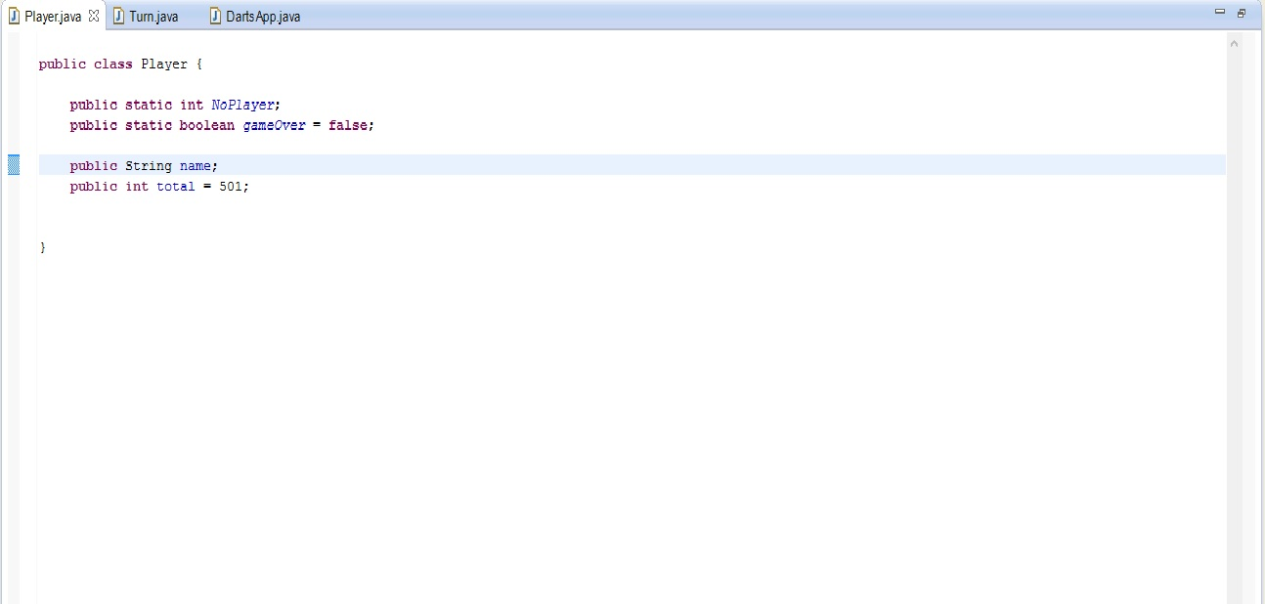

The Turn class is used to store the variables for creating instances of a turn for each player they are used in the Turn Array, some of the variables that are contained in the Turn Class are;

* A integer for recording a players First Throw
* A integer for recording a players Second Throw
* A integer for recording a players Third Throw
* 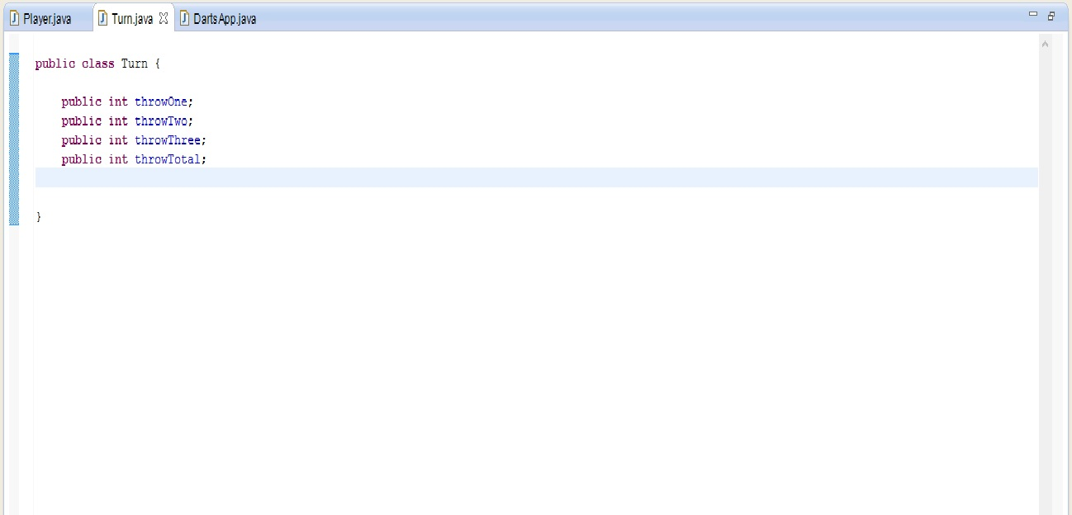A integer for recording the Total of all three Throws

Once the game has been played the original menu will appear and ask the user to select from the three options if the user for instance selected to replay the game then they would see displayed on the screen the entire game that they have just played including each players throw the total of the throws and their 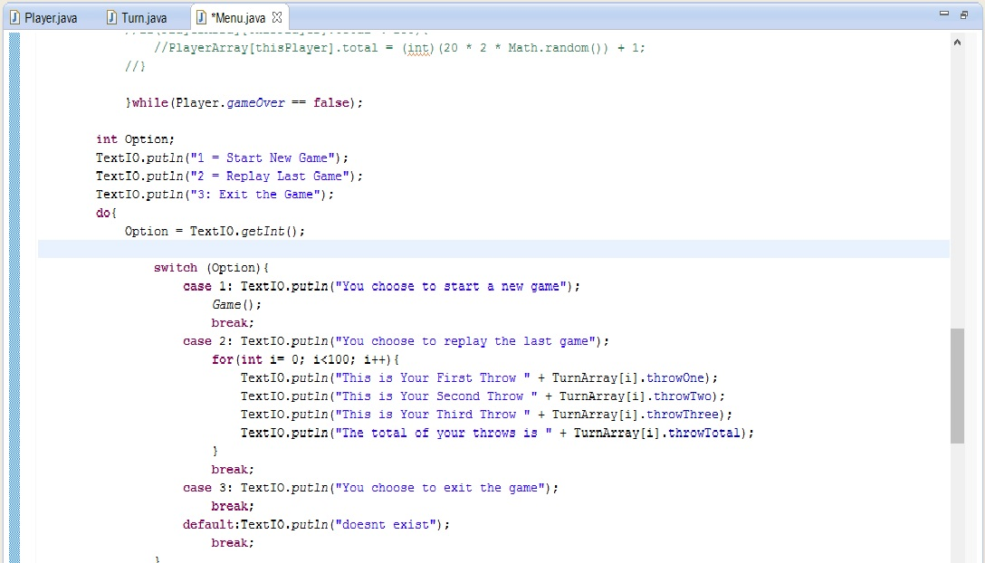score.

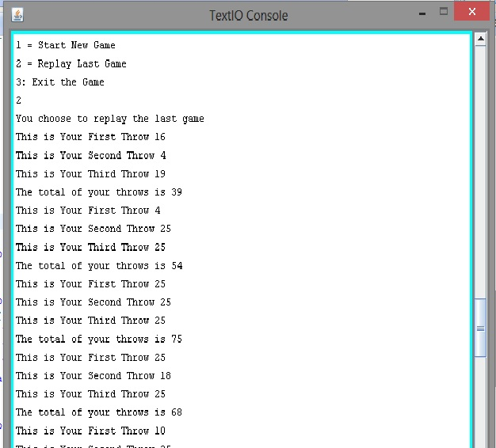Critical Appraisal

When me and arek started the project we just dove straight in to figuring out the code and inevitably we ran into problems and realised that we should have planned the program out from the beginning which is a lesson that I personally will learn from.

The complications and little bugs that we have are that the scoring system point five is not what was asked to be done which my partner sent me and said it was correct so that was the individual point that he chose to do. When the relay game is selected after the user has completed a game it will only run so far then stop saying there is a problem with the text io line which worked until a certain point which I tried to fix but ended up making worse so just kept it as displaying part of the array. Also when the menu is displayed again and the user chooses option 1 again it will only display the players first throw and wont go any further I thought this was due to the players total not being 501 so I put in a piece of code to reset it but with no prevail. Also the game does not finish on a double or bulls eye to be honest I was focused on getting the game to stop first and other things but I did attempt at it but the condition did not work so I just commented it out.

Arek

When we started the project me and arek started the project but in about week 3 of the project he failed to turn up and when I contacted him he said that he was ill and that he had family commitments and when I contacted him we said which individual part will we do so arek said that he would do point five and the a throw method that you will see in the code is the only part he coded and I worked on the rest by myself with little or no help.

Myself

I myself put a lot of time and effort into this project because out of all the modules this trimester intro to programming is the one I enjoyed. A part from the fact that I should have planned out the program more I feel that my best efforts were made to make a darts game the way I approached this project was not the best way as I was trying to do to many things at once. I completed most of the tasks that were set upon me.

Points

Given the amount of work that I did and the little that arek did I will award myself 8 points and arek just 2.